# init:Error

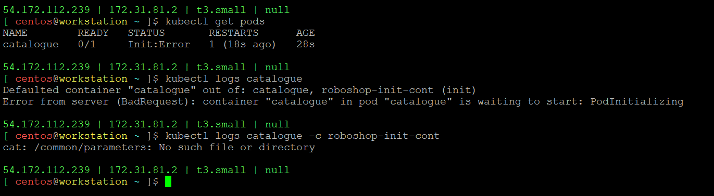

1. Init container don’t have volume to store the /common/parameters
2. IAM Role is not attached to Pod to pull the parameters values